Player Name | Uniform Number | Jersey Received | Deposit Received | Jersey Returned | Deposit Returned
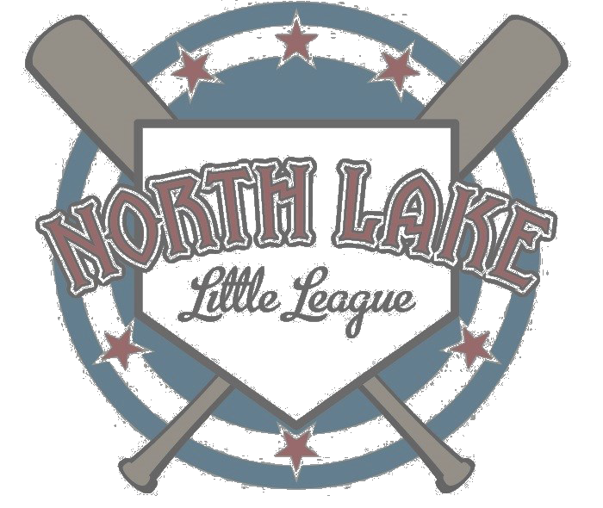
The North Lake Little League Board of Directors has an obligation to every Member of our organization to manage NLLL resources so as to keep registrations costs as low as possible. In the past several years, NLLL has incurred unnecessary costs when NLLL-issued uniforms were not returned by players at the end of the season. To full fill NLLL’s financial responsibilities to our Members, the Board adopted at our Feb 9, 2014 meeting, the following equipment deposit policy:

Equipment Deposit Policy: Players will be required to bring a $40 deposit (cash or check) to their Manager in order to receive their uniforms. The deposit will be held, undeposited, by the Treasurer until the last game of the season. Player deposits will be returned upon receipt of their uniform.
North Lake Little League
Equipment Deposit Policy

